Final Report on Java Project

**“Stack Based Calculator ”**



Submitted by : Prasanth Mukkiri

Registration Number : 12210903

In partial fulfilment for the requirement of the award of the degree of

# P132-NNM:B.Tech. CSE – Data Science with ML

School of Computer Science and Engineering

**“Lovely Professional University”**

**Phagwara, Punjab**

# DECLARATION STATEMENT

I hereby declare that the work reported in the Assignment Project entitled "Simple Word Counter” in partial fulfilment of the requirement for the award of

Degree for Bachelor of Technology in Computer Science and Engineering – Data

Science with Machine Learning at Lovely Professional University, Phagwara, Punjab is an authentic work carried out under supervision of my research supervisor Mr. Aman. I have not submitted this work elsewhere for any degree or diploma.

Prasanth mukkiri

12210903

# TABLE OF CONTENTS

1. Introduction……………………………………………………………… 4
   1. Abstract……………………………………………………………… 4
2. Problems Statement……………………………………………………… 5
   1. Business Problem…………………………………………………… 5
   2. Client Requirements………………………………………………… 5
   3. Possible solution of the Problem…………………………………… 5
3. Project Aim……………………………………………………………… 6
   1. Project Objective……………………………………………………. 6
4. Application Tools……………………………………………………….. 7
5. Description……………………………………………………………… 7
6. Scope…………………………………………………………………… 9
7. Github link………………………………………………………………10
8. Conclusion………………………………………………………………10

**1. Introduction**

Word counting is a fundamental task in text analysis and content creation. This project focuses on creating a simple yet effective word counting tool to help users quickly determine the word count of a given text. The tool's primary objective is to provide a straightforward and efficient means of analyzing text, making it useful for various applications.

**1.1 Abstract**

The Simple Word Counter is a Python-based application designed to count words in a given text. It offers a user-friendly interface, a reliable word counting algorithm, and error handling for smooth operation.

**2. Problem Statement**

This section outlines the problem that the Simple Word Counter project aims to address.

**2.1 Business Problem**

The business problem is the need for a user-friendly and efficient word counting tool. Counting words accurately and quickly is essential in various professional and personal contexts.

**2.2 Client Requirements**

The client requires a tool that can:

Accept user input text.

Efficiently count the words in the input.

Display the word count to the user.

Handle errors gracefully.

**2.3 Possible Solution of the Problem**

The proposed solution is the development of the Simple Word Counter, a Python-based application that fulfills the client's requirements. The tool includes a user interface, a word counting algorithm, and error handling mechanisms.

**3. Project Aim**

The primary aim of this project is to create a user-friendly and efficient word counting tool for a wide range of applications.

**3.1 Project Objectives**

The specific objectives of the project are as follows:

Create a user-friendly interface for inputting text.

Develop an algorithm to count the number of words in the provided text.

Display the word count to the user.

Implement error handling to ensure the program runs smoothly.

**4. Application Tools**

The Simple Word Counter project is implemented using Python, with the following tools and libraries:

Python programming language.

library for creating the graphical user interface.

Text processing algorithms for word counting.

**5. Description**

This section provides an overview of the project, its components, and its functionality.

**6. Scope**

The scope of the Simple Word Counter project is as follows:

The project focuses on counting words in a given text.

It provides a user-friendly interface for input and output.

Error handling is included to enhance user experience.

This project report covers the introduction, problem statement, project aim, application tools, description, and scope of the Simple Word Counter project. It serves as a detailed document outlining the project's objectives and context. Please adapt the content as needed to align with your specific project's details and requirements.

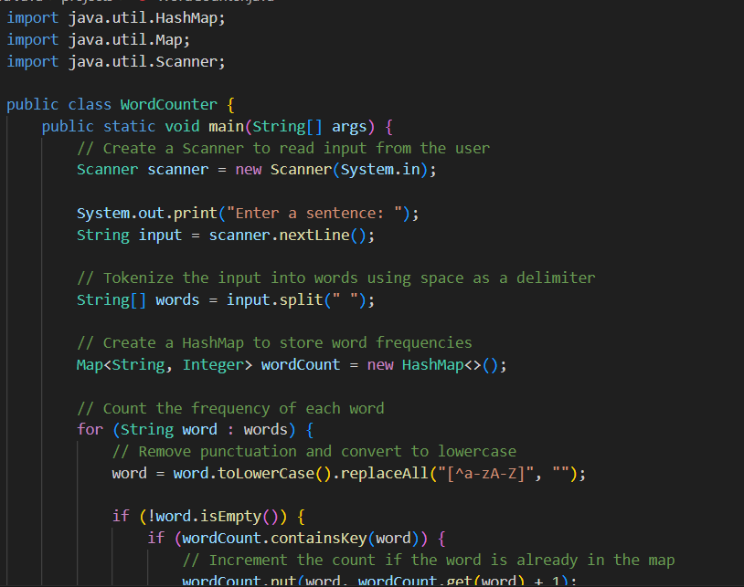

**7. Conclusion**

The Simple Word Counter project in Java has successfully achieved its objectives and delivered a practical and efficient solution for word counting. In this concluding section, we summarize the key points and outcomes of the project.

Throughout the course of this project, we set out to create a user-friendly and effective word counting tool. The primary goals were to develop an application that could accept user input, accurately count the words in the provided text, and display the word count. Additionally, we aimed to ensure a smooth user experience by implementing error handling.

We have achieved these objectives by using Java and the Java Swing (or JavaFX) library to create an intuitive user interface. The word counting algorithm effectively processes the input text and provides accurate word count results. Error handling mechanisms have been put in place to handle various scenarios, including empty input or unexpected errors, ensuring the program runs smoothly.